RASTER MOSAICING AND CLIPPING

Steps:

1. Download the required shape files of the county.

The required counties of California are Kern and Tulera which will be available in <https://geodata.lib.berkeley.edu/catalog/ark28722-s7vp4m>

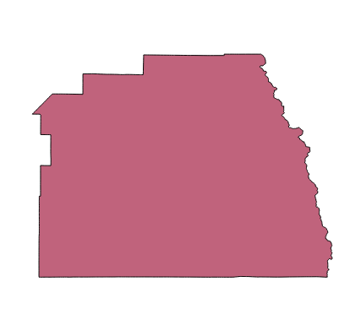

*Figure. Shapefile for Tulare County (*[*Source*](https://geodata.lib.berkeley.edu/catalog/ark28722-s7vp4m)*)*

1. Determine the county in Earth explorer by adding shape file (dropdown criteria select country , county, county name).

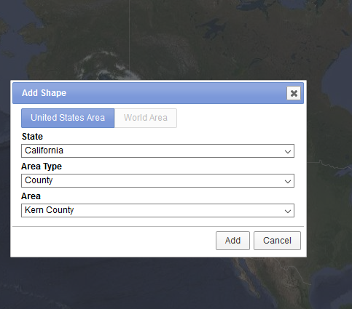

*Figure. Adding shapefile for dataset([Source](https://earthexplorer.usgs.gov/))*

1. Use the shape file criteria to generate result for Landsat 8.

Address for each county, Shape file, Date Range (01/01/2013 – 12/31/2017), Dataset as Landsat 8 OLI/TIRS C1 Level-1

1. Assign the additional criteria’s and download file.

Data Type Level-1 as ‘Level1 TP’

1. Check using foot prints the tiles needed for coverage of the county completely (min 2 to 4 will be needed).

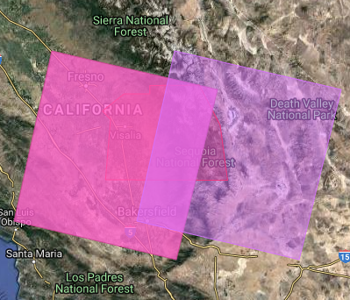

*Figure. Footprints for Tulare County (*[*Source*](https://earthexplorer.usgs.gov/)*)*

1. Then perform the merging process by initially loading the band 10 raster files to QGIS for all the downloaded tiles (that is 3 to 4 Band 10 .tif files from the downloads). Similar merging operations require for Band 3 and Band 4 TIFs of each county dataset. (<https://www.youtube.com/watch?v=c8YgcTmxuQA>)

Merging operation is done by following steps:

1. Raster → Miscellaneous → Merge
2. Input Files : Files to be merged  
   Output File: Output of merging operation to be stored  
   Check ‘No data value as 0’
3. OK will execute the GDAL Merging algorithm and result will be generated and loaded to the project

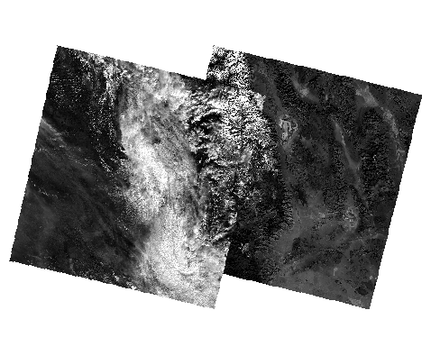

*Figure. Merged tiles for Tulare County*

1. After successful merge load the shape file (mentioned in Step 3) also to QGIS along with the merged output file.
2. Then do clipping operation for the merged output and shape file. For clipping operation do the following steps:-
3. Raster → Extraction → Clipper
4. Input File : Merged output file which is a raster file  
   Output File: Clipped output will be stored in this file  
   Check ‘No data value as 0’ field

Since clipping Mode is clipping with mask layer, select the shape file of the county as Mask Layer

1. OK will execute GDAL Clipping algorithm in the background and resulted with a clipped file which is loaded to the current project in the QGIS

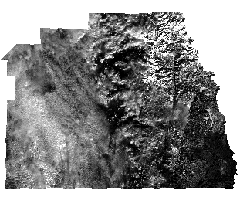

*Figure. Clipped output*